The New Proposal System:

Help documentation for Users

The proposal system allows users to submit proposals for future experiments at CLF (Central Laser Facility) or ISIS Neutron and Muon Source. These facilities accept proposal submissions within certain time windows (called “calls” or “rounds”); all the proposals submitted to a call will be reviewed by a panel, and some proposals will be allocated time. The proposal system collects the information the panel require to consider your experiment idea.

This document has detailed information for users of the proposal system, to give you context and step-by-step guidance on using the system. Please use the contents table below to find the information you require.
Please note, this document will be updated over time. The most recent version can be found at https://www.clf.stfc.ac.uk/Pages/Proposal-System.aspx

Contents
Accessing the proposal system 3
Accessing the system directly 3
Accessing the system through the main facilities site 4
Looking at your proposals 5
Creating a proposal 7
Adding information to a proposal 8
Filling in a proposal 8
Preparation to fill out a proposal 9
Looking ahead in the proposal 9
Questions in a proposal 10
Saving a proposal 10
Submit your proposal 11
What happens when a proposal is submitted 11
Editing submitted proposals 11
Email notifications 11
Steps to submitting a proposal 11
Visibility of proposals 14
Finding, editing, cloning and deleting proposals 14
Downloading your proposal 16
Download just before you submit 16
Download at any point 16
Updating your details 17
Changing the information we hold about you 17
Allowing yourself to be added to proposals 19
Logging out 19
Glossary 20
Further help 21
The User Office 21

If you are struggling to submit a proposal, or have any feedback on this document, please contact our support team (email: FacilitiesBusinessSystem@stfc.ac.uk )

Accessing the proposal system
There are two ways of accessing the system: either directly through its web address, or from the main facilities menu. The first lets you access the system faster, especially if you bookmark the address in your web browser. The second may be more convenient if you also need to access some of our other applications, or for people who do not know the system’s address.

Accessing the system directly
- Open https://proposal.facilities.rl.ac.uk/ in any supported web browser. Our supported browsers are up-to-date versions of Firefox, Chrome, Edge, Safari and Opera. Internet Explorer is not supported, and the proposal system will not work correctly while using it. Once you have opened the URL, you may be redirected to the main facilities login page (as seen in Figure 1).
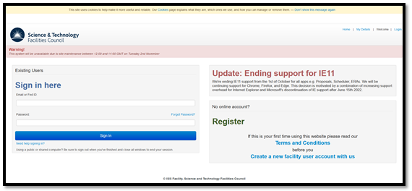
Figure 1: Login page for main facilities menu
- If you already have an account, enter your email address and password. If not, create one using the “Create a new facility user account with us” link on the lower right of the page; enter your details and follow the instructions on the page, then open the URL in step 1 again. Once you have entered your login details, you should be redirected to the proposals system (as seen in Figure 2).
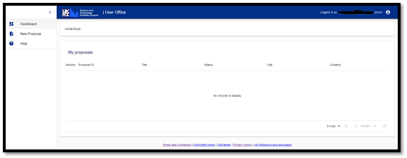
Figure 2: Dashboard view of Proposal System

Accessing the system through the main facilities site
- Open https://users.facilities.rl.ac.uk/ in any supported web browser. Our supported browsers are up-to-date versions of Firefox, Chrome, Edge, Safari and Opera. Internet Explorer is not supported, and the proposal system will not work correctly while using it. Once you have opened the URL, you should be redirected to the main facilities login page (as seen in Figure 1 above).
- If you already have an account, enter your email address and password. If not, create one using the “Create a new facilities account with us” link on the lower right of the page; enter your details and follow the instructions on the page, then open the URL in step 1 again. Once you have entered your login details, you should see the main facilities dashboard (Figure 3 below).
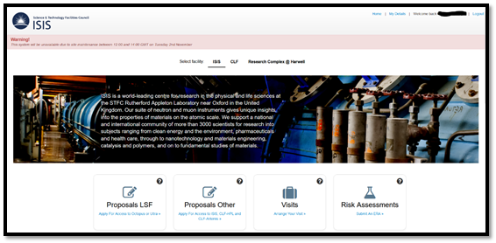
Figure 3: Landing page of main facilities site with some tiles visible at bottom
- Click on the appropriate tile for you to submit a proposal (in our example, this is “Proposals LSF”, as seen in Figure 4).
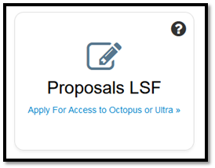
Figure 4: Tile for accessing Proposal System
- You should be redirected to the proposal system
Figure 5: Dashboard view of Proposal System
- For quicker access, you can also add a bookmark for https://proposal.facilities.rl.ac.uk/. This will take you directly to the proposal system if you’re already logged in, but if you are not or your session has expired you will first be redirected to the login page.

Looking at your proposals
To view your proposal(s), you must be logged in to the proposal submission site. When you are logged in, you will see the dashboard (Figure 6), with three key areas to be aware of:
- In the main area of the screen, you will see any proposals you have started work on or previously submitted. These proposals may be ones you created (making you the principal investigator), or ones where you were added as a co-investigator. Please note, this is a new proposal submission system, you will only see certain information from your previous proposals. All of your previous proposal data should be available in the future. If you need access any historical proposal’s, please contact: FacilitiesBusinessSystem@stfc.ac.uk.
- Across the top of the screen, you will see a blue bar (highlighted in orange in image below). To the right-hand side of the blue bar, you can see the account you’re currently logged in with (hidden in screenshot below) and the person icon allows you to log out.
- To the left of the screen, you see icons in the minimised sidebar (highlighted in green in image below). To see more, you can click on the hamburger icon (stack of three horizontal lines to the far left of the blue bar) to maximise the sidebar.
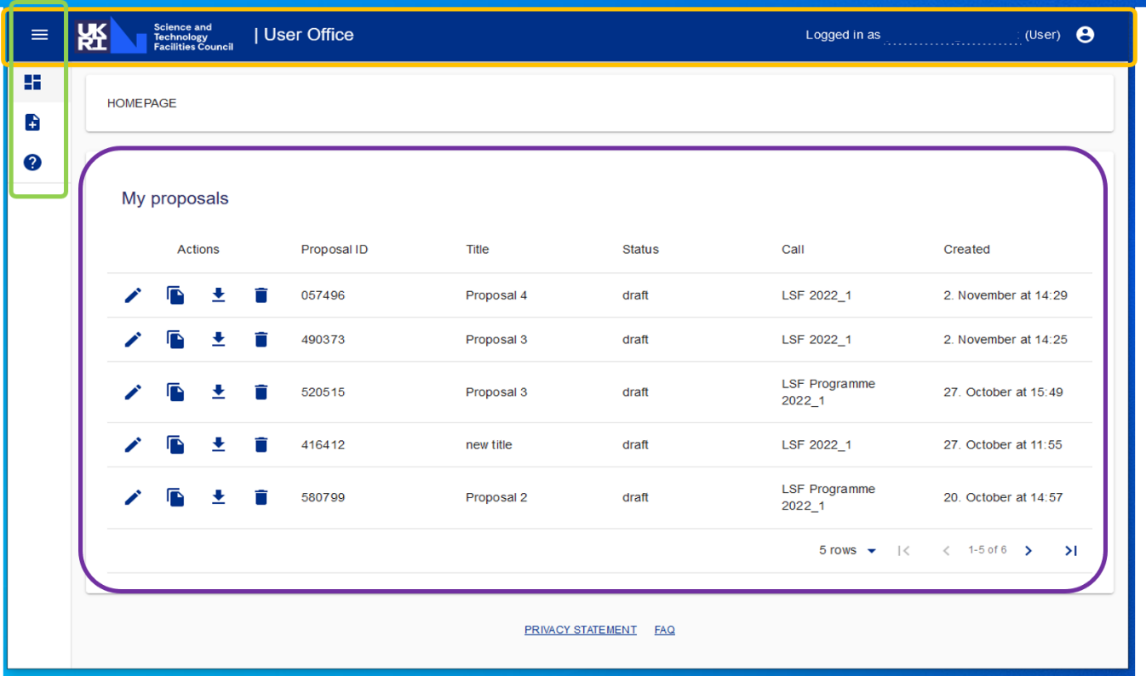
Figure 6: Dashboard for Proposal System.
The left sidebar (highlighted in green above) can be maximised (showing words and icons) or minimised (showing only icons). To maximise the left sidebar, click on the hamburger icon (stack of three horizontal lines to the far left of the blue bar, see Figure 7). To make the left sidebar smaller again, click on the arrow (highlighted in red in Figure 8).
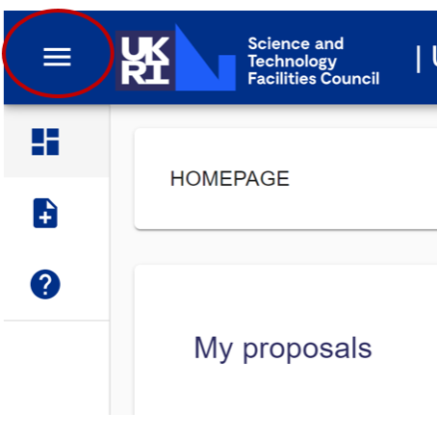
Figure 7: The hamburger icon - this maximises the left sidebar
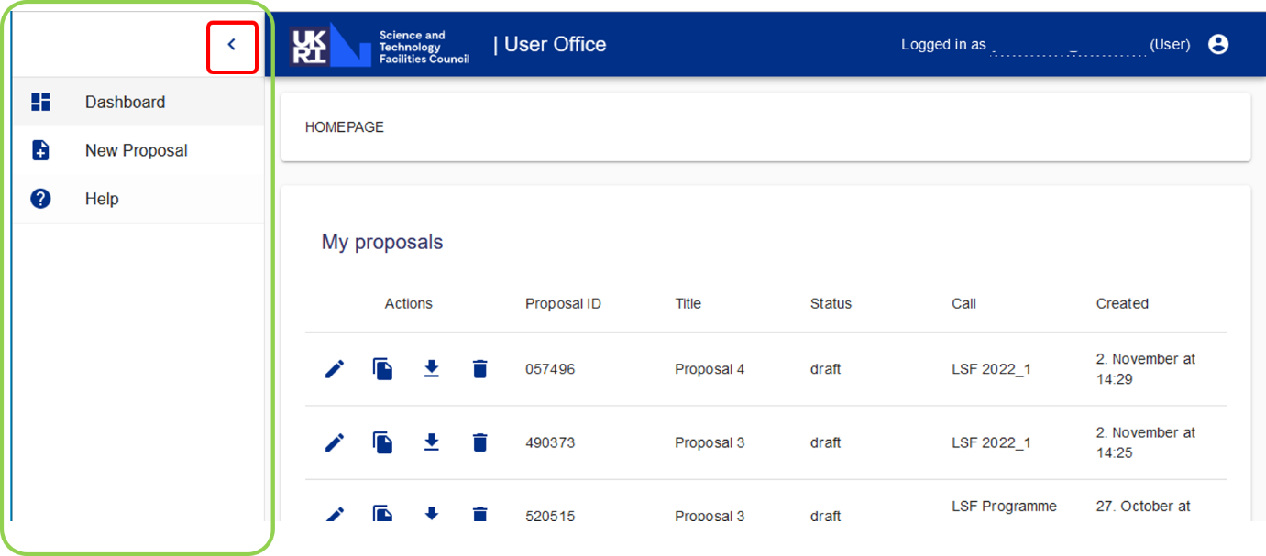
Figure 8: Maximised left sidebar (green) can be minimised with sideways arrow (red)

Creating a proposal
To create a proposal, you must go to the proposal system. Once you log in to the Proposal System, you will automatically be looking at your dashboard. You will be able to see any draft or submitted proposals you are associated with.
- Expand the side bar by clicking on the hamburger icon (three lines to the left of the UKRI/STFC logo, circled in red in Figure 7).
- Click on “New Proposal” button
- Select the call that you wish to submit to.
The number of calls available at any time can vary, so you may only have one option. If there are more and you are unsure which to collect, please contact the appropriate user office for further information.
ISIS Neutron and Muon Source User Office: +44 (0)1235 445592
CLF User Office: Tel +44 (0)1235 445090
- Once you select the appropriate call, you can then start filling out the proposal.

Adding information to a proposal
Filling in a proposal is an essential part of the proposal submission process. It provides the panel with the information they need to rate your proposal and if successful, it provides the instrument scientists and support staff with key information required to set up and conduct your experiment. The following information appears later in this section, but you may wish to jump to these:
- Preparation to fill out a proposal
- Looking ahead in the proposal
- Questions in a proposal

Filling in a proposal
Please remember, the questions and how these appear on different steps (pages), is different for each call, so these instructions may not match exactly with what you see. Please answer the questions that you see on the system.
- Find your proposal on the dashboard and click ‘Edit proposal’
- Ensure that the principal investigator is set to the appropriate person and add any co-proposers (additional users involved with an experiment, also called Co-Investigators or Co-Is) by clicking the edit icon, and searching for them using their email address. If you cannot find someone you expect to find, please send them these instructions and direct them to Allowing yourself to be added to proposals. If you still cannot find them, double check you are using the correct email for them (the one they use to access their account). If issues persist, please contact our support team.
- Enter any other information required on the first step (see the numbered steps at the top, as in Figure 9). It is likely this first step is going to ask for Title, Abstract and other basic information about your proposal.
- Click “SAVE AND CONTINUE”.
- The second step could be Facility and Funding – allowing you to select the specific facility/instrument you wish to use, give further details about experiment type, and also cover funding methods. There are likely to be dropdown fields and you may need to enter values. If it is unclear what information is required, please contact the user office. Click “SAVE AND CONTINUE”.
- The third step could be more information about experiment requirements, including technical requirements. For example, one call requires a comprehensive overview of technical requirements (with a limit of 900 characters). Samples used in the experiment can be added. Click “SAVE AND CONTINUE”.
- Another step could ask about publications; this is important to capture the scientific backing of your proposal. Please detail all publications used to research your scientific proposal. Click “SAVE AND CONTINUE”.
- Another step could ask about consumables. You can click the “ADD” button to add each item, and then complete the questions in the pop-up. Click “SAVE AND CONTINUE”.
- Another step could ask for a Science Case. This will be a PDF file upload ONLY, and there can be different restrictions on this file, for example max of 2 pages and 2MB. Files exceeding limits will not be able to be uploaded. You have to tick to agree to specifications of the science case before you can click “SAVE AND CONTINUE”.
- A final step will be confirming you agree to terms of access. You should be able to click to read these and then tick a box to accept. Click “SAVE AND CONTINUE”.
- Once you have completed all the steps (there may be more or less than described here), you will see a review page and can review the details of your proposal. If you notice an error, use the steps at the top of the screen to navigate back to the relevant section. Remember to click “SAVE” after making any edits.
- If the proposal is correct and complete, you are ready to submit your proposal.

Preparation to fill out a proposal
While the questions for each call may vary slightly, in general, in order to fill out a proposal, you will require the following information. Please note you can look ahead in the questions to check if any additional information will be required.
- A digital copy of your science case
- Full contact details of all experimenters
  - Full name
  - Email
  - Contact details
  - Establishment
- Supporting information for your proposal
  - Abstract
  - Publications
  - Sample information

Looking ahead in the proposal
Note that when you are filling out the proposal, the questions are not all visible at once, but spread across multiple steps; you see the titles of these steps at the top of the screen. Each step can have one or more questions. You can look ahead to the next step(s) and view the questions. You can NOT fill out these questions until you have completed the previous questions (i.e. questions must be filled out in order, but you can check what information will be required before starting the process). To look ahead, click on the buttons at the top of the screen. The step you are currently looking at will appear in black text and with the number in an orange circle. The completed steps will appear in grey text with the number in a blue circle.
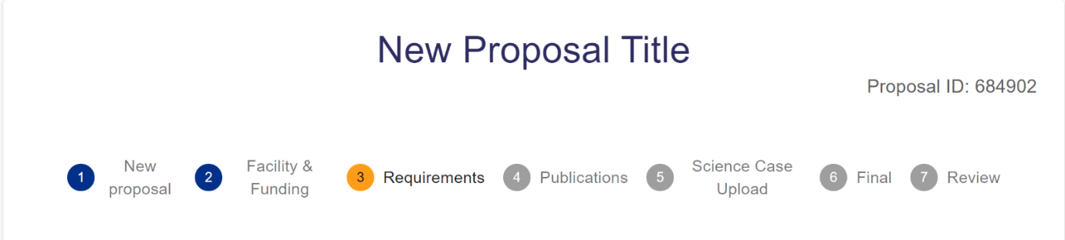
Figure 9: Example steps for a proposal, where steps 1 and 2 are complete, and step 3 is currently being completed

Questions in a proposal
Each call can have a different set of questions, so the instructions for filling out a proposal can only be general and do not give step-by-step guidance on each question. If you have questions about a specific question (e.g. how much detail is required, or what a term means), please contact the user office. Some questions are considered particularly important; essential fields in the proposal system are denoted by the * icon next to the relevant field. You will be unable to progress past a page without filling in all fields with this feature. You can look ahead to see all the questions that you will be asked.
There are a few types of question, most of which should be clear how to answer (e.g. for choices, you will see drop down options, for values, you will be able to enter numbers, etc.).
You are able to add co-proposers (or Co-Is) and edit the principal investigator (which defaults to the proposal creator). This is done by clicking the edit icon, searching for a person using their email address, and then clicking add. Please note that this must be the email address they use for their Facility User account, and they need to have made themselves searchable for this to work. If you cannot find someone, please send them these instructions and point them to the Allow yourself to be added to proposals section and confirm the email address they are using. If you are still having issues, please contact our support team.

Saving a proposal
To save a proposal you can either click the ‘SAVE’ button which will save your changes, or you can click the ‘SAVE AND CONTINUE’ button which will save your changes and take you to the next step of the proposal to fill out.
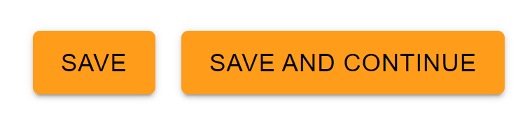
Figure 10: On each step (page) of filling out a proposal, you will see two orange buttons
If the save is successful, you will see a pop up on towards the top your screen, indicating your changes have been saved.
Figure 11: A green pop up to the top of the screen confirms a successful save

If you do not submit your proposal, the proposal will appear in your dashboard as a draft. You can go back and submit this proposal at any point before the call deadline. You will not be able to submit the proposal after the deadline.

Submit your proposal

What happens when a proposal is submitted
Submitting a proposal indicates that it is the final version of the document and is ready for review. The pre-submission Proposal ID is NOT the final ID for the proposal; the number will change once submitted. The proposal then moves to the next stage in its workflow (which can be different for different calls but is likely to be making it available for review). After a proposal is submitted, it can no longer be deleted – if you need it to be deleted, please contact our support team to request the deletion. You can clone a proposal that has been submitted; the proposal that is generated will be in the draft phrase.

Editing submitted proposals
Proposals can be edited at any point up until the call deadline; they can also be edited and submitted by anyone assigned to the proposal (both principal investigators and co-investigators). Please note, multiple people may have access to the same proposal, so any edits should be discussed with other people assigned to the proposal.

Email notifications
As it is expected that an experimental team discusses and agrees upon their proposal, the system does not generate email notifications as people edit proposals. When a proposal is submitted, an email is sent to everyone assigned to the proposal to notify them of the submission. After a proposal has been submitted, if it is subsequently edited, this does not generate email notifications for co-proposers.

Steps to submitting a proposal
- Following the instructions to Create a proposal and then fill in a proposal, you will have gone through all the steps (pages of questions, navigable at the top of the screen, see Figure 9 above), and the final step is likely to be called Review and show you the information for your Proposal (see Figure 12 below).
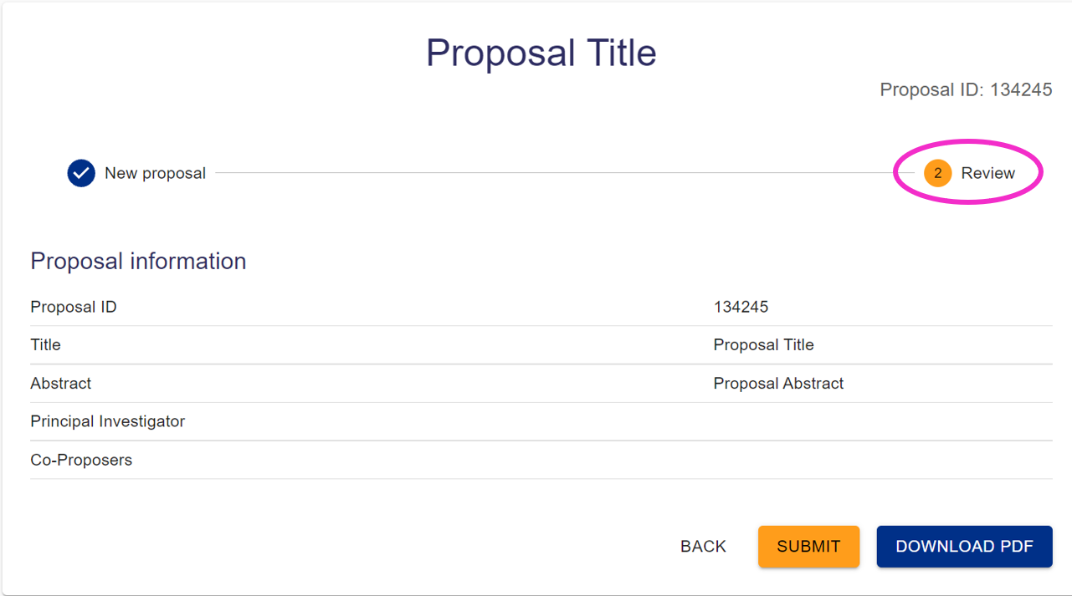
Figure 12: You may have many different steps, but the final step is likely to be Review (circled in pink here), which presents a summary of the information you have filled in
- Click the “SUBMIT” button (in orange at bottom)
- A confirmation dialogue appears. Click “OK”
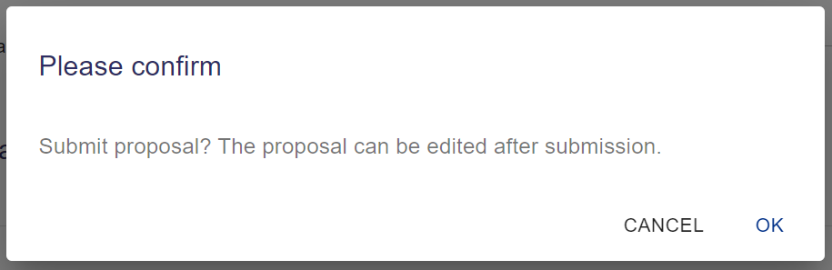
Figure 13: Pop up confirmation box
- A green pop-up box confirming the submission will appear at the top of the screen. The submit button will be greyed out and instead will show a tick and say SUBMITTED
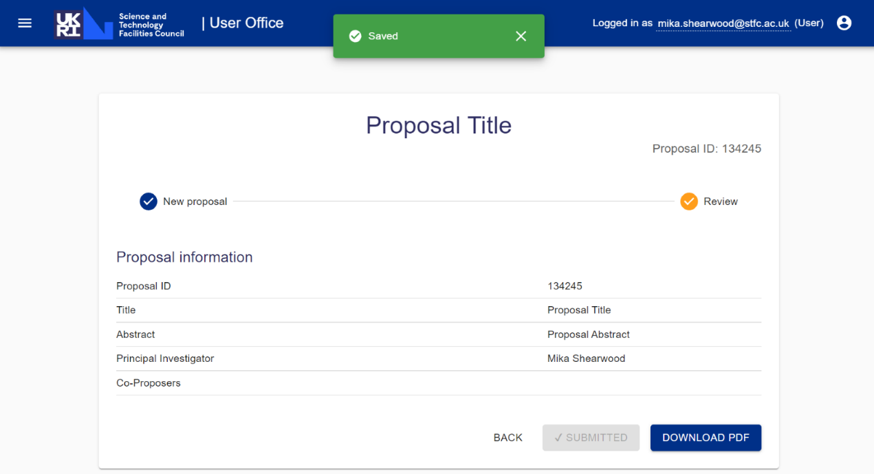
Figure 14: Review screen after successful submission
- In the case that you see an error or do not see the Saved pop-up, you can check if the proposal was successfully submitted by returning to the dashboard (see Figure 16 below) and checking the status. If it wasn’t submitted (i.e. still says draft in the Status column), try again later or after logging out and in again. If the issue persists, contact our support team.
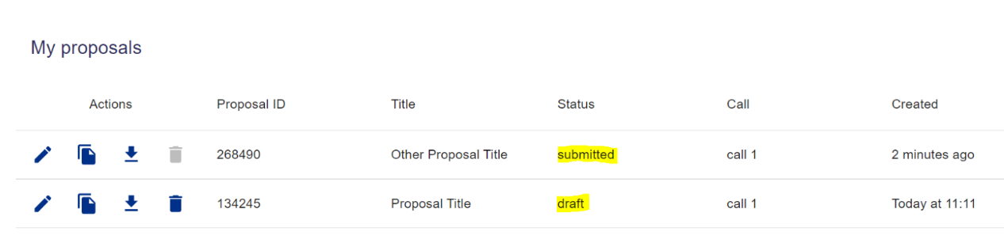
Figure 15: You can see on the dashboard if a proposal has been submitted by looking at the Status column
- Once successfully submitted, you can view your proposal on the dashboard (homepage), which you can navigate to using the left sidebar. Remember if the sidebar is minimised that you can maximise it by using the Hamburger icon (three lines) in the top left corner.
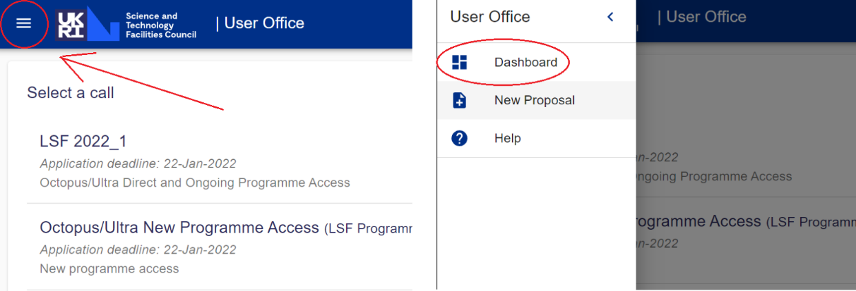
Figure 16: Hamburger icon indicated to left will maximise the sidebar, so you can select Dashboard (shown on right image)

Visibility of proposals
When a proposal is in the draft stage, it is visible to:
- Principal investigator (the person who created the proposal)
- Instrument Scientists (generally these are scientific staff at STFC, but may include some administrative STFC staff)
- Co-proposers (people added by the principal investigator – this can be anyone with a Facilities User account with their settings allowing them to be added)
- User Officers (staff at STFC supporting administration of proposal submission process)
The same set of people can see proposals when they are submitted. The proposal will also be made available to the Facility Access Panel.
Please note that a proposal can be edited by the principal investigator AND by anyone added as a co-proposer. Any changes they make will be visible to anyone else named on the proposal. Edits to proposals are notified to the Principal Investigator via email only if the proposal has been submitted. Before submission proposal editing is not notified. A co-investigator is unable to remove themselves from a proposal and must request someone else removes them. This can be another co-investigator, the principal investigator, or the user office.

Finding, editing, cloning and deleting proposals
In order to edit, clone or delete a proposal, you need to be logged into the proposal system.
- Click on dashboard the left sidebar (icon highlighted in red below)
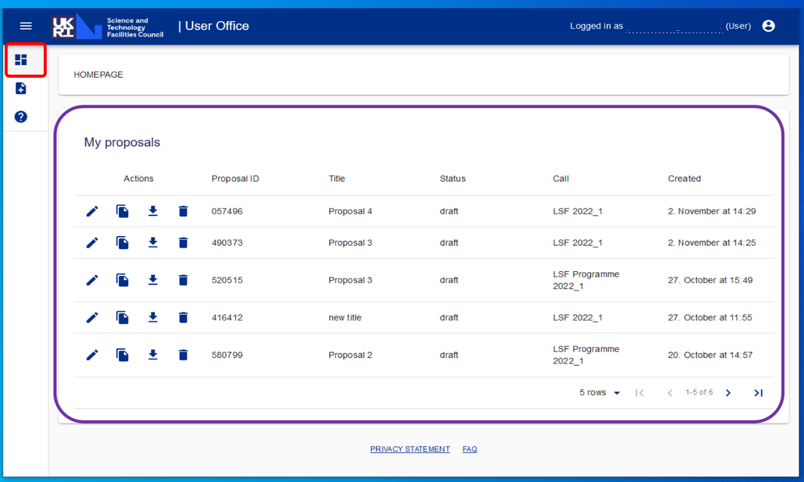
Figure 17: Proposal System with dashboard icon highlighted with red box
- You will see all your proposals (highlighted in purple above). For each you see:
  - Action buttons – a selection of icons showing the available actions for that proposal
  - Proposal ID – a number
  - Title – what you called your proposal
  - Status – draft (not yet submitted) or submitted
  - Call – which call the proposal was/will be submitted to (please note, each call can have different questions)
  - Created – the date the proposal was created
- To edit a proposal which is not yet submitted, click the “Edit proposal” pencil icon (green in image below). You can then make your desired changes (remembering to save or save and continue).
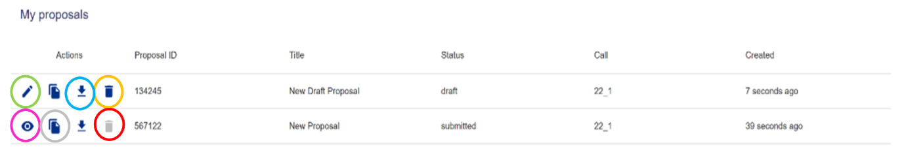
Figure 18: Action buttons - what you can do with your proposals
- To edit a submitted proposal, click on the “View proposal” eye icon (pink in image above). You can then make your desired changes (remembering to save or save and continue). You can edit a submitted proposal before the call deadline.
- To download a proposal, click the download icon (arrow pointing down to horizontal line, circled blue in image above)
- To delete a proposal, click the “Delete proposal” bin icon (orange in image above). Note that this is only possible for draft proposals. A submitted proposal cannot be deleted and this icon is in grey and cannot be clicked on (circled red in image above).
- You can create a copy of a proposal by clicking on the “clone proposal” copy icon (circled in grey above). You will be prompted to select the call to which you want to clone the proposal. After choosing the appropriate call, click the “CLONE TO CALL” button. The proposal should now appear in the dashboard with the correct call showing in the Call column. Please note that different calls may have different questions, so check this carefully.

Downloading your proposal
You can download your proposal before you submit or at any point. This will create a PDF with the title YYYY_Yoursurname_ProposalID. Please note that the words “Left blank” will appear if you have not answered a question.

Download just before you submit
You can download a PDF when you submit your proposal; when you are filling in the proposal, the final step (page of questions) is Review, and next to the “SUBMIT” button is a “DOWNLOAD PROPOSAL” button (highlighted red below).
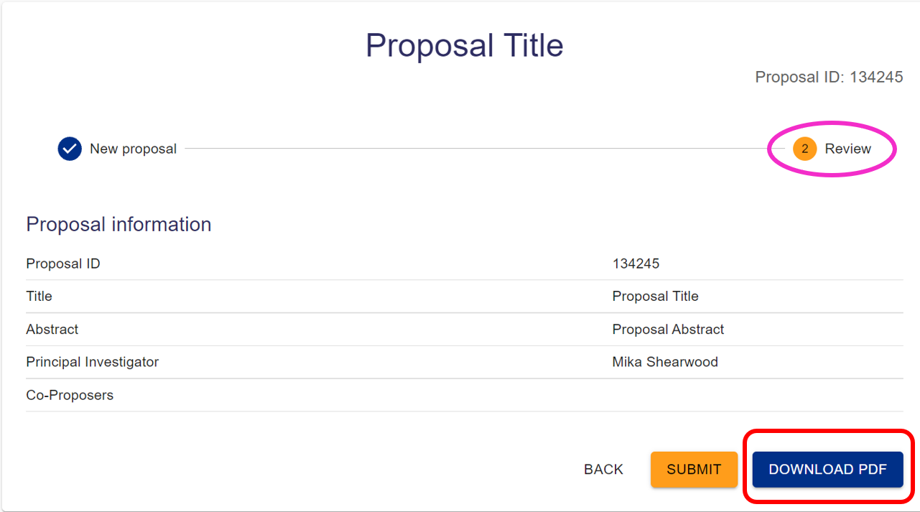
Figure 19: DOWNLOAD PDF is available on the Review page next to the SUBMIT option

Download at any point
Alternatively, you can download a PDF copy of your proposal at any point from the dashboard. You can download both draft and submitted proposals. While looking at the dashboard which shows your proposals, in the Actions area to the left, you will see the download icon. It is available for proposals in draft stage (circled in blue below) and submitted proposals (green circle). Click the download icon in the correct row.
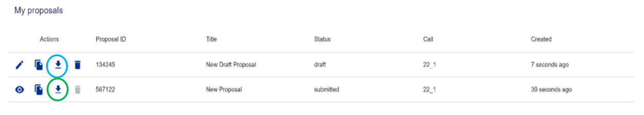
Figure 20: All proposals will have a download icon (downward arrow to line), whether draft or submitted

Updating your details
At any point you may wish to update the information we hold about you; while filling out a proposal, you see the institution we believe you are associated with, and you may need to update this. You also have the option to add other people to your proposal and can see their institutions. If any information about a person is incorrect, that person needs to log in to the user system and update their information. If you are unable to add a person to a proposal, please check they have created an account, and have made themselves searchable.

Changing the information we hold about you
- Open https://users.facilities.rl.ac.uk/ in any supported web browser. Our supported browsers are up-to-date versions of Firefox, Chrome, Edge, Safari and Opera. Internet Explorer is not supported, and the proposal system will not work correctly while using it. Unless you are already logged in, you will be redirected to the login page, where you need to enter your email address and password. 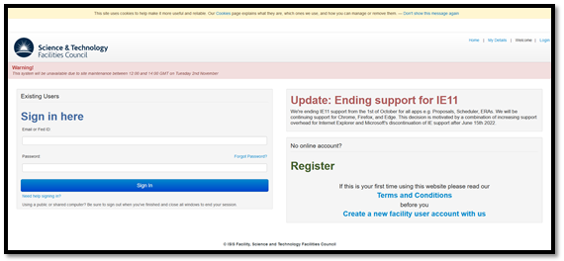
Figure 21: Login page for Facility User account
- Once you have entered your login details, you should see the main facilities dashboard, with a range of tiles available to you
Figure 22: Logged in view of Facility User account with tiles at bottom
- Click on the “Your Details” tile. Note that the tiles are NOT in alphabetical order.
- The page opens on the My Details tab (highlighted in red box below). The first section is called Summary and you cannot change this information here, but you can change it in the other sections, for example if you need to change your name, you can change that in Details. You can minimise and maximise each section by clicking on the grey bar.
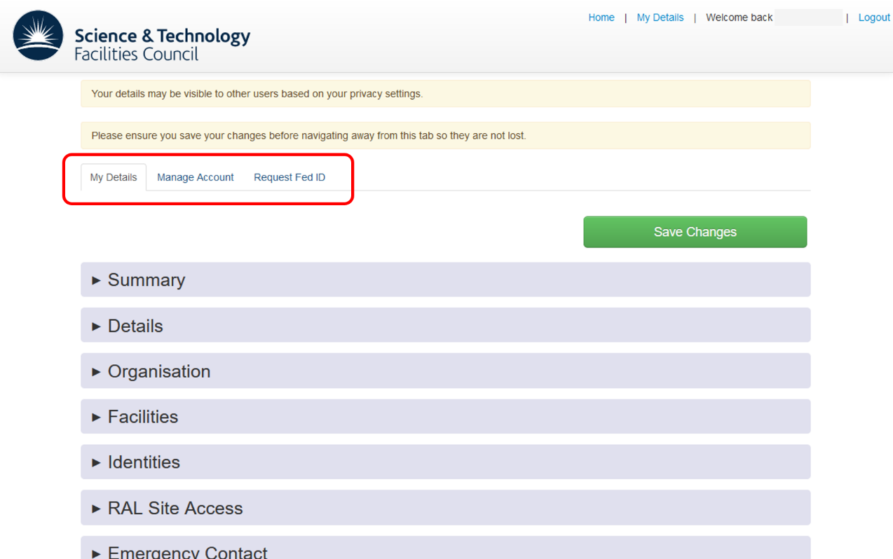
Figure 23: My details tab of Your details gives you options to change the details we hold about you
- Go to the section(s) where you wish to make changes and make your changes. If you spotted that the organisation you are associated with is incorrect, you will want to change this in the Organisation section.
- Click the green “Save Changes” button (available at the top and bottom).

Allowing yourself to be added to proposals
- Go to “Your Details” (follow instructions for changing the information we hold about you) and look at the My Details tab
- Click on Privacy Settings (near the bottom of the sections)
- Tick the box that says “Please tick here to allow other users to add you to any proposals and visits. They will only be able to find you if they know your email address.”
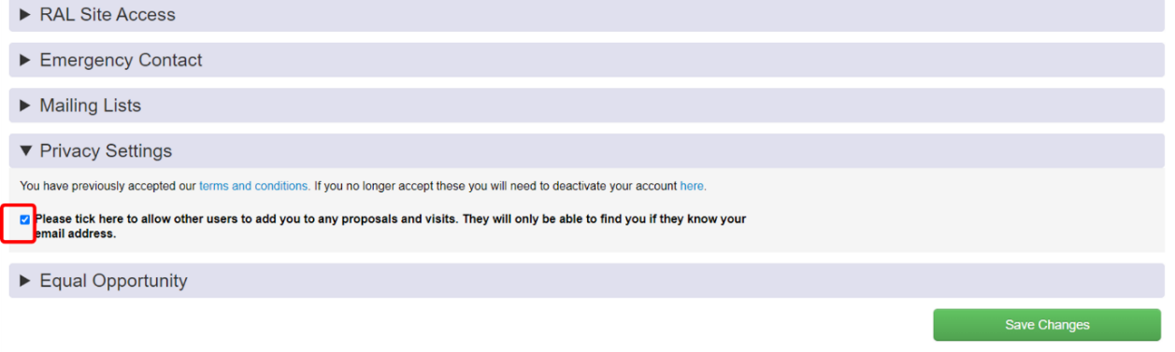
Figure 24: Red box highlighting the tick box that needs to be enabled for other people to be able to add you to proposals
- If you do not tick this box, even if you have an account, other people will be unable to add you as a co-proposer on proposals they create. If you do tick this box, only people who know your email address will be able to add you to proposals. You will then see the proposals you have been added to when you log in to the proposal system.
- Click the green “Save Changes” button (available at the top and bottom of page)

Logging out
- To log out, click on the person icon to the right hand side of the blue bar at the top (highlighted in red below)
Figure 25: Logout using the person icon to the right of the blue bar at the top
- Select “Logout”. This will log you out of the proposals system and redirect you to the main login page.
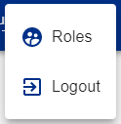
Figure 26: Options seen when clicking on person icon

Glossary
call | The time window within which proposals are accepted. All proposals submitted to the same call will generally be reviewed at the same time by panel(s). Also called rounds.
CLF | Central Laser Facility, a facility at Rutherford Appleton Laboratory, Harwell Campus, near Didcot  For more information, see www.clf.stfc.ac.uk
Co-I | A shortened form of co-investigator
co-investigator | This is a person who is added to a proposal, but was not the person who created the proposal (the principal investigator). Being added to a proposal means you can edit the proposal and submit it.
co-proposer | Used interchangeably with co-investigator
hamburger icon | Stack of three horizontal lines used to maximise the left sidebar. See Figure 8 in Looking at your proposals
instrument scientist | An STFC staff member, generally scientific staff
ISIS | ISIS Neutron and Muon Source, a facility at Rutherford Appleton Laboratory, Harwell Campus, near Didcot  For more information, see www.isis.stfc.ac.uk
panel | When a proposal submission deadline is reached, all proposals are reviewed by a group of experts and rated, and then some proposals are successful and can go ahead.
PI | A shortened form of principal investigator
principal investigator | The person who creates the proposal becomes the principal investigator by default. They will be the primary contact for the proposal and subsequent experiment (if the proposal is successful).
proposal | If someone has an idea for an experiment to be carried out at our facilities, they need to answer a series of questions about their idea. The answers to the questions form the proposal.
round | Word used interchangeably with call
user | At both facilities, user generally means someone from outside of STFC coming and making use of the facilities (carrying out an experiment), however within this documentation, user refers to anyone with a Facilities User account (the account required to use the Proposal System)
User Office | A group of staff focused on assisting all users of the facilities. Contact details are below
User Officer | A permission level within the Proposal System, enabling STFC staff to support the proposal submission process.

Further help
There are three possible routes for help. If in doubt, please contact the user office (Practical), who will be able to redirect your query if required.
- Scientific
E.g. What is the capability of equipment x at the facility?
Please look on the appropriate website (www.clf.stfc.ac.uk or www.isis.stfc.ac.uk), contact STFC staff contacts you already have, or if you cannot find an answer, contact the user office to be put in touch with someone who can help
- Practical
E.g. Which call should I submit to? What information is required for question x? How do I arrange a visit from place y?
Please contact the User Office
- Software
E.g. Why do I see an error message? Why can’t I follow these instructions?
Please contact our support team via email: FacilitiesBusinessSystem@stfc.ac.uk

The User Office
Both CLF and ISIS have staff to support users from applying to use the facility onwards. Both are located at Reception Building (R75) at Rutherford Appleton Laboratory, Harwell Campus, Didcot, Oxfordshire, OX11 0QX, UK
- CLF User Office
  - Email: clf@stfc.ac.uk
  - Tel: +44(0)1235 445090 (ext. 5090​​)
- ISIS Neutron and Muon Source User Office
  - Email: isisuo@stfc.ac.uk
  - Tel: +44 1235 445592 (ext 5592​​)

